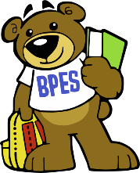Bushy Park Science Fair 2022 Registration form
All students in Pre-K to 5th grade are encouraged to participate by conducting their own science experiment at home and displaying their results proudly at the BPES Science Fair. All boards are due by April 20th and should be brought to the cafeteria for display and judging.

Name of student ___________________________
Grade _______ Teacher’s Name _______________
Other Student on the Project _________________
Grade _______ Teacher’s Name _______________
Name of your Project _______________________
Type of Project:
- Experiment
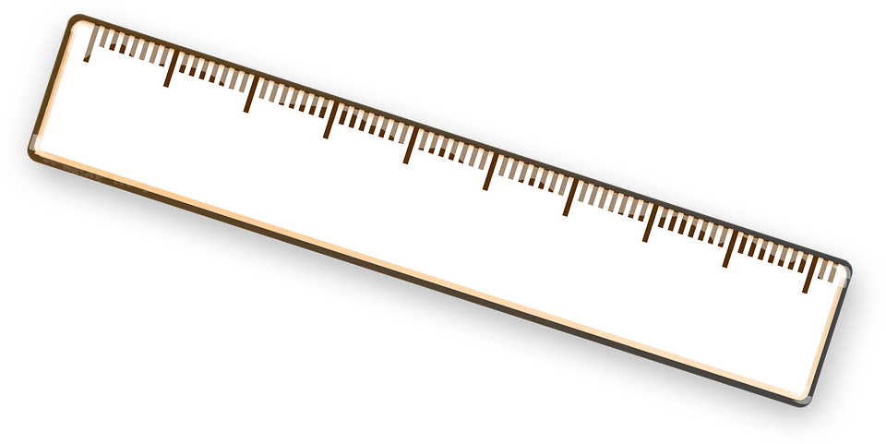
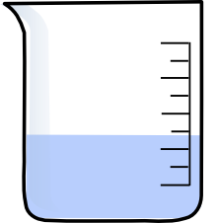
- Model
- Observation
- Collection
- Intervention
- I don’t know
For more information: https://www.bushyparkpta.org/science-fair
To register online via QR code: 